Python.org installation and Use

Contents

Installation 2

Quick Test 6

Method 1: 6

Method 2: 8

IDLE – Simple Development and Learning 12

IDLE – create a new python file 13

Creating a new code folder 16

Making / Changing / Running a Program 18

Reading a saved file for edit / running 18

Idle Help 22

IDLE Python Docs 23

The Python installation of python.org, complete with the IDLE environment provides an excellent starting point for the aspiring Python developer.

NOTE: View in print mode, for Read Mode and Draft Mode don't appear to handle graphics well.

# Installation

Go to [www.python.org](http://www.python.org)

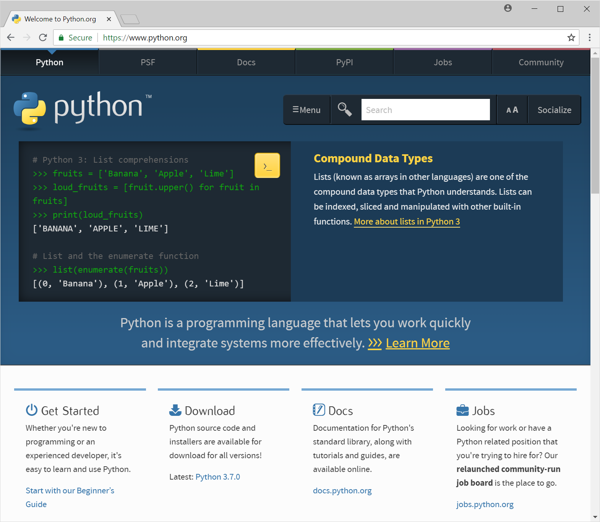

Download Latest: Python 3.7.0 – Click Python 3.7.0 in bottom middle.

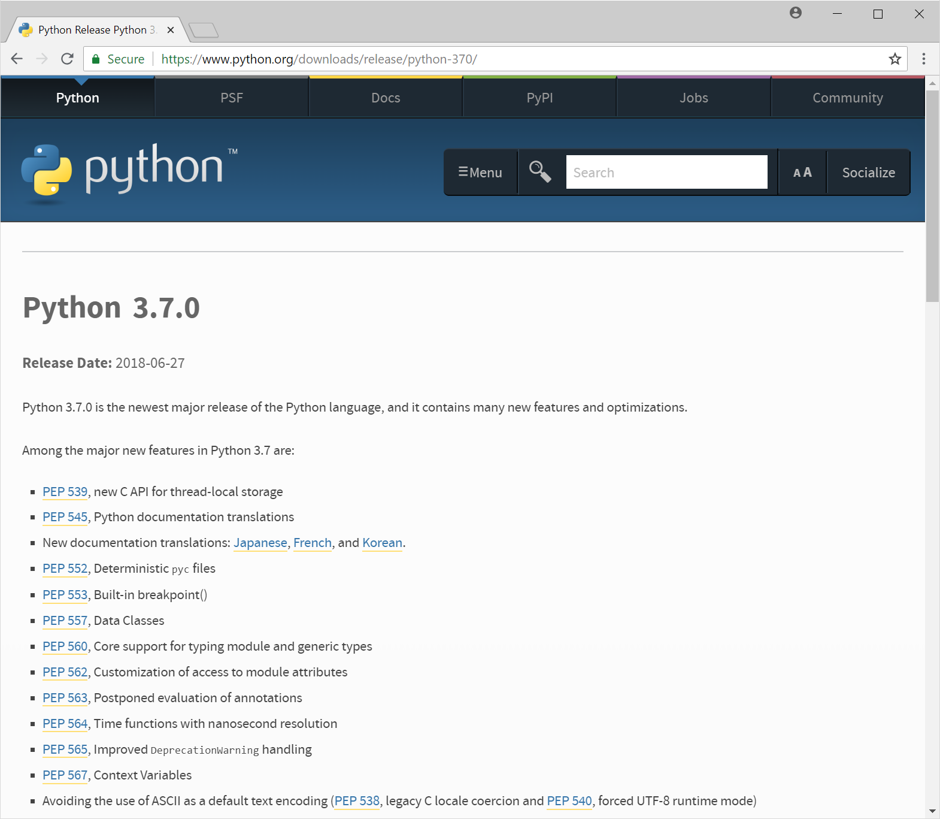

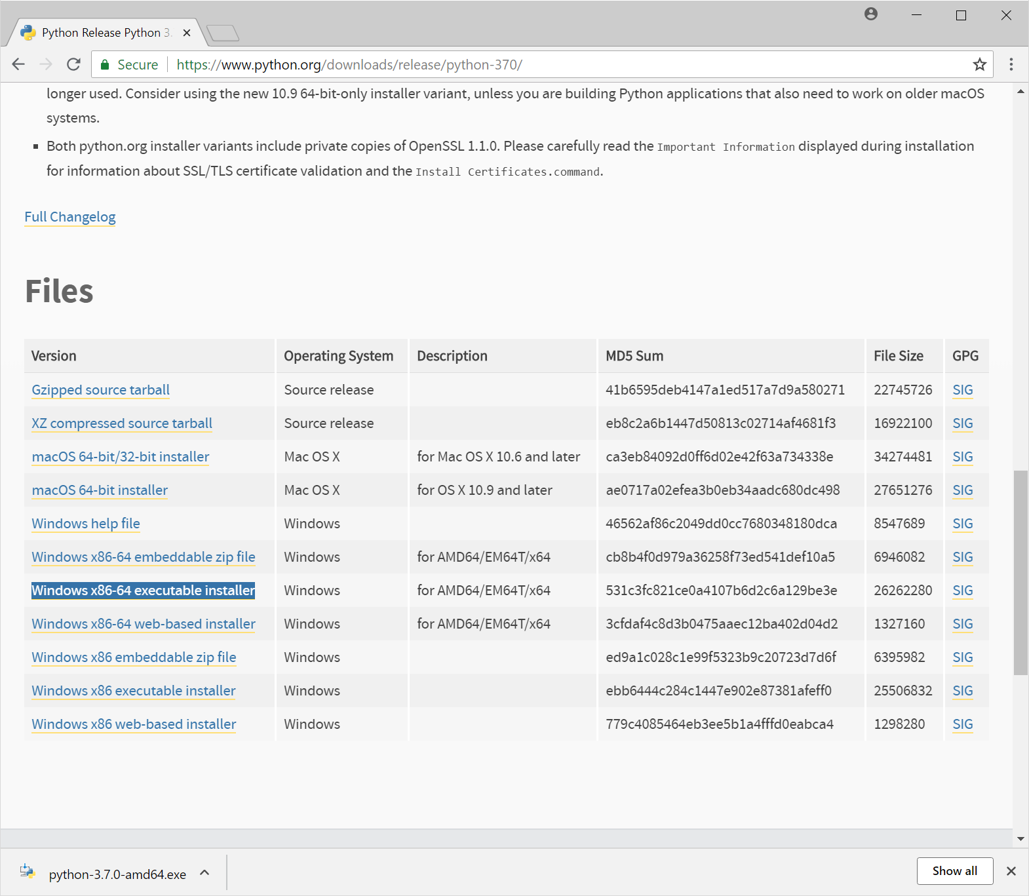

Use Windows x86-64executable installer by clicking [Windows x86-64 executable installer](https://www.python.org/ftp/python/3.7.0/python-3.7.0-amd64.exe)

In Files section at the bottom. ( If you have a different computer type, use a different file, e.g., [Windows x86 executable installer](https://www.python.org/ftp/python/3.7.0/python-3.7.0.exe) for windows 32 bit)

After a few seconds “python-3.7.0-amd64” appears in the lower left hand corner of this window.

Click this “python-3.7.0-amd64”

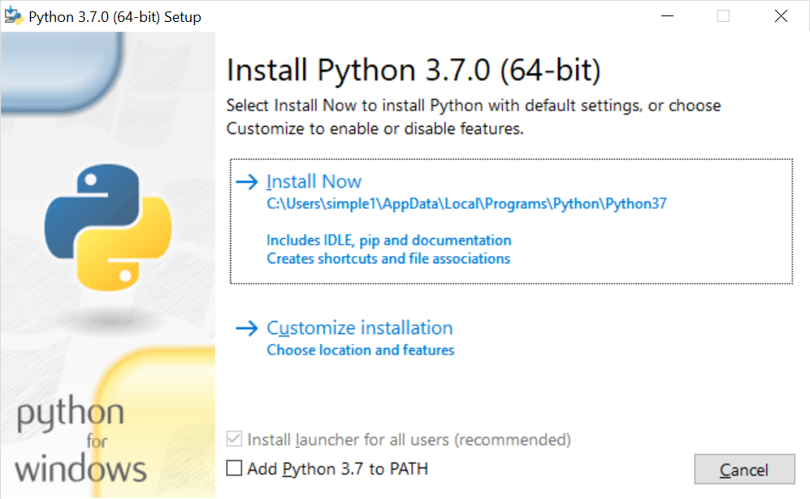

Set Add Python 3.7 to PATH

Click “🡪 Install Now”.

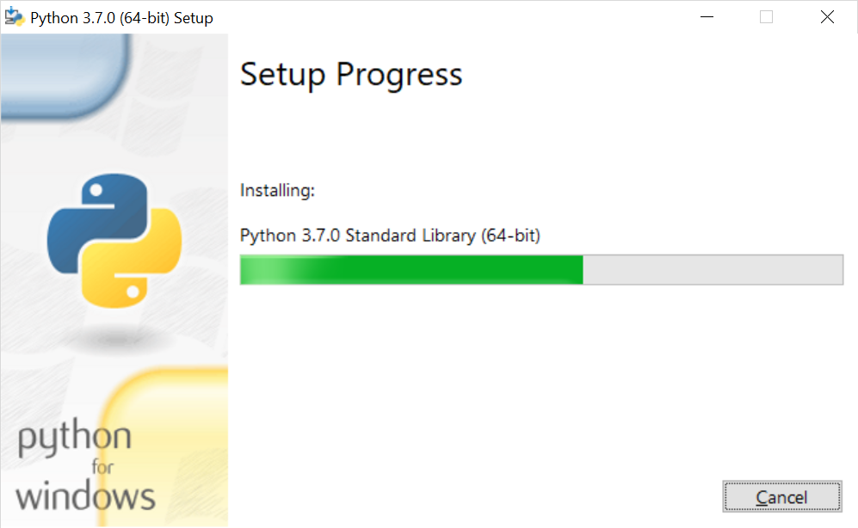

About a minute later the following should appear:

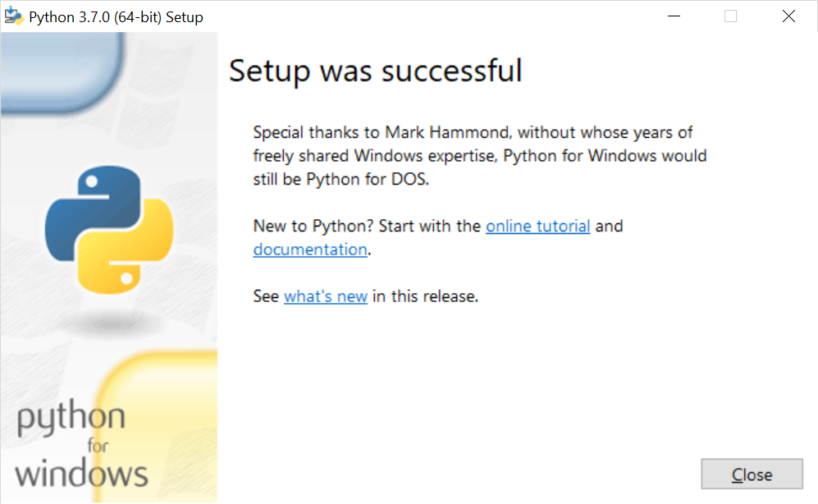

# Quick Test

## Method 1:

Start 🡪 Programs 🡪 Python 3.7 🡪 Python 3.7 (64 bit)

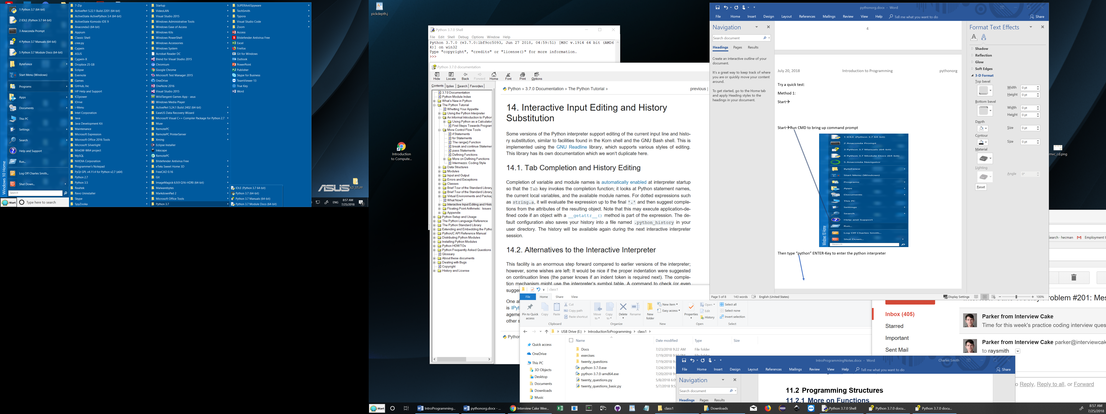

The Python console window should appear:

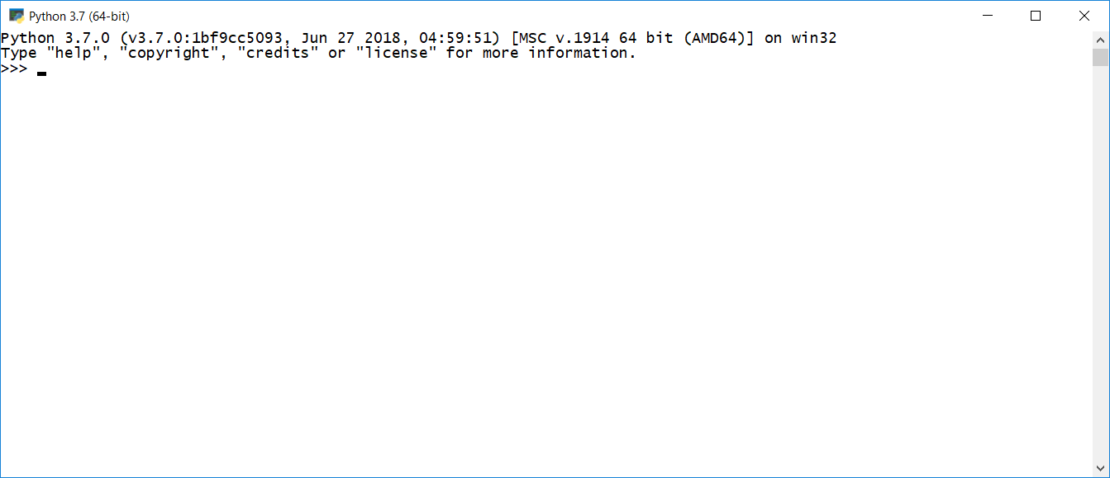

You are free to enter python statements to execute:

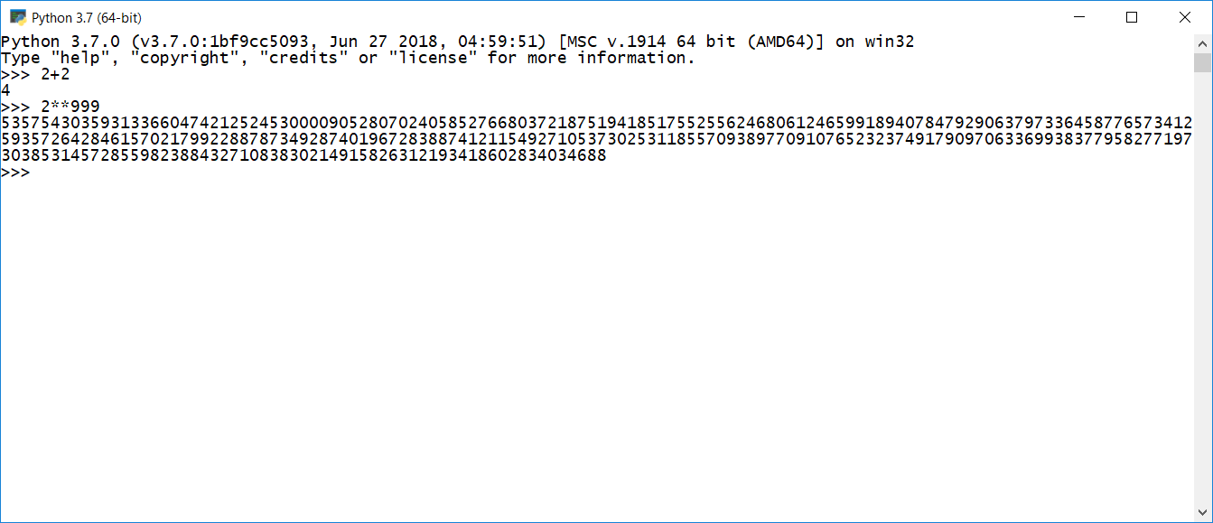

## Method 2:

Start🡪Run CMD to bring up command prompt

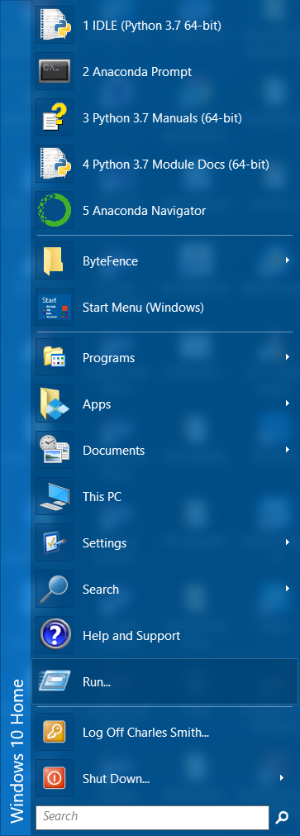

Then type “python” ENTER-Key to enter the python interpreter

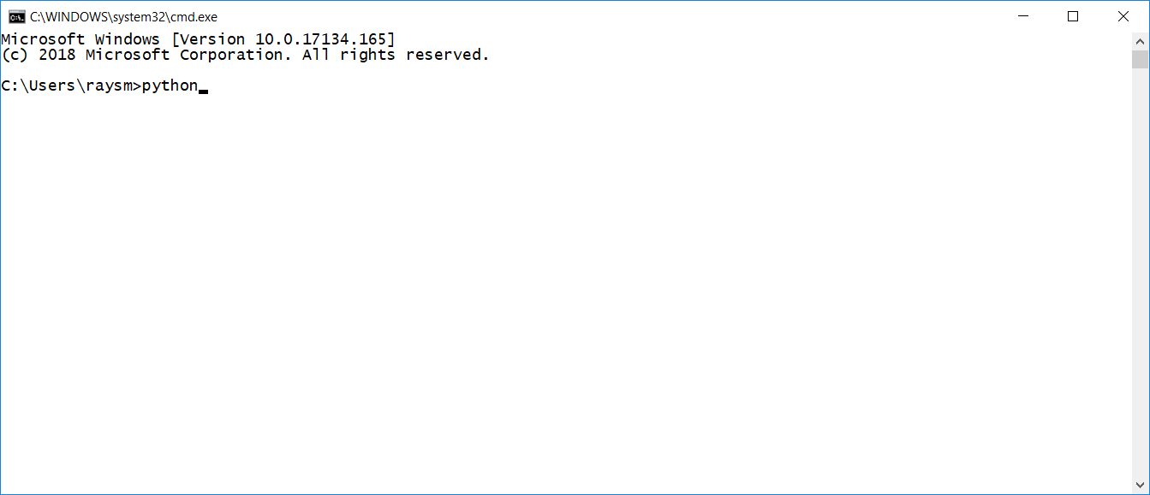

The python console window should appear.

You can now enter python statements like below.

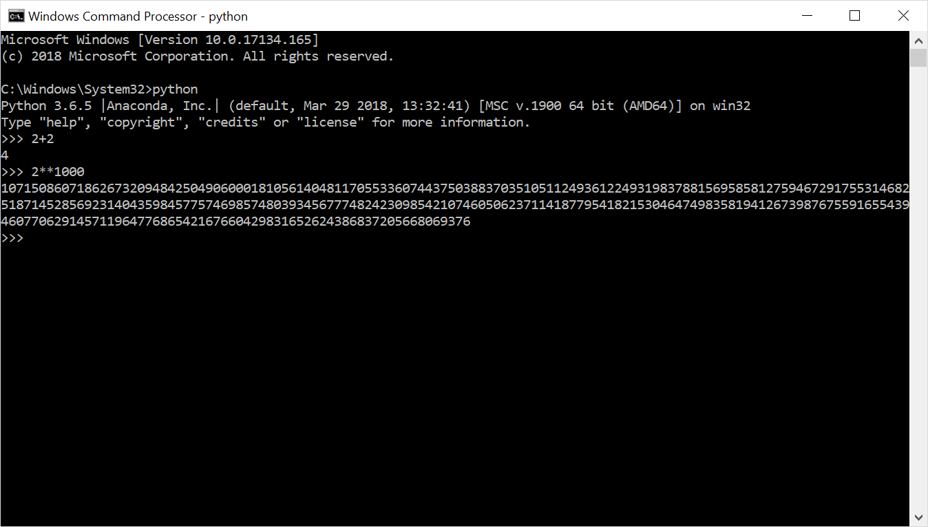

The following options are available for your edification:

Selecting documentation gives:

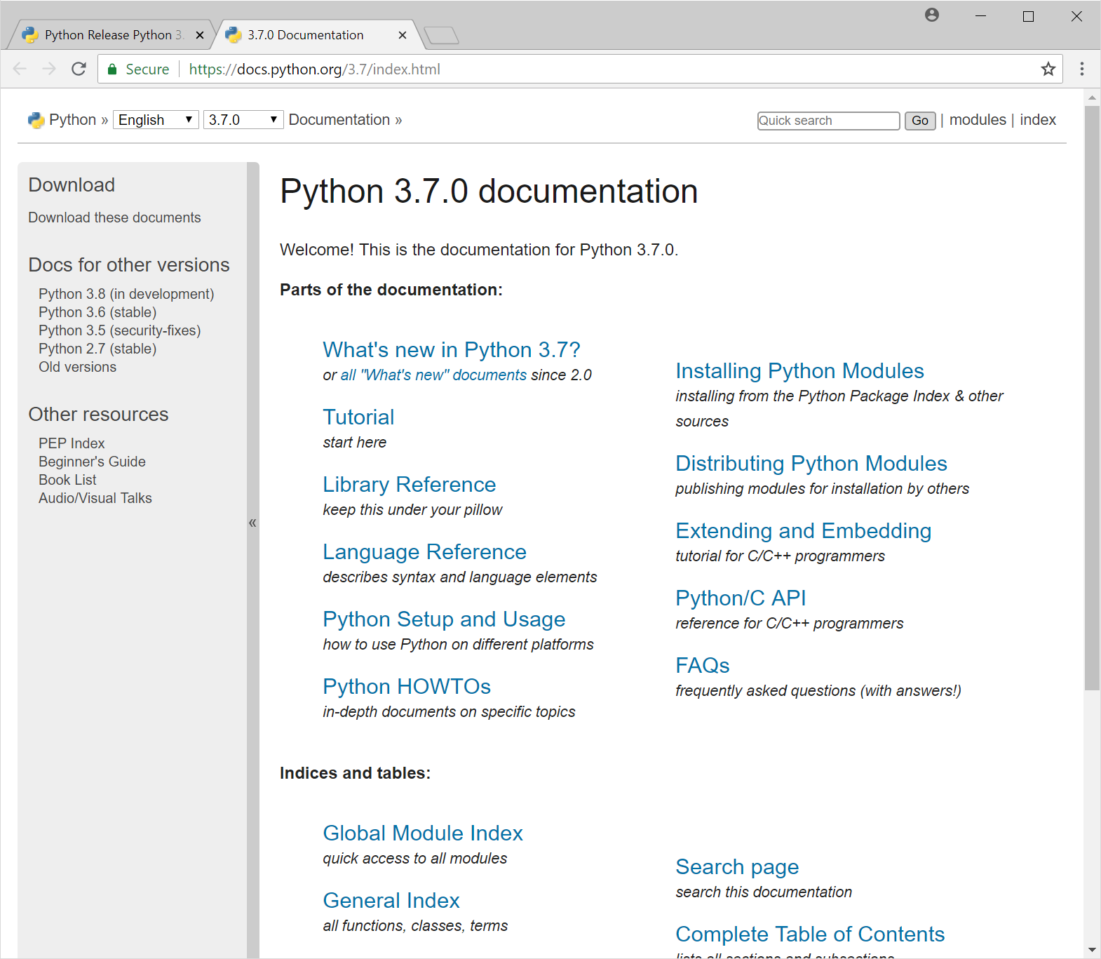

Selecting “online tutorial” gives:

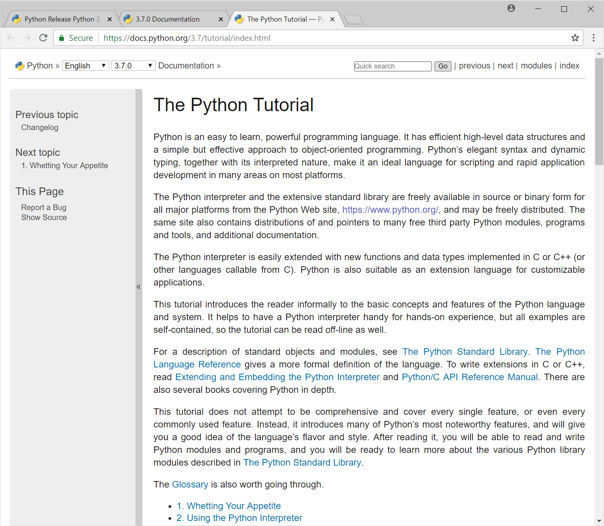

# IDLE – Simple Development and Learning

Start 🡪 Programs 🡪 Python 3.7🡪 IDLE

(see Quick Test Method 1 above)

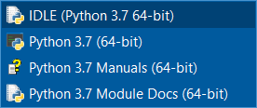

The following IDLE window appears:

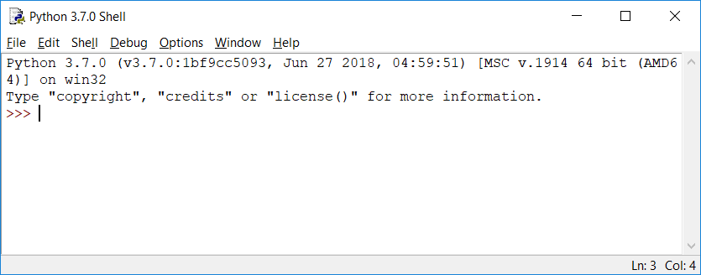

It can be used as a Python shell for learning.

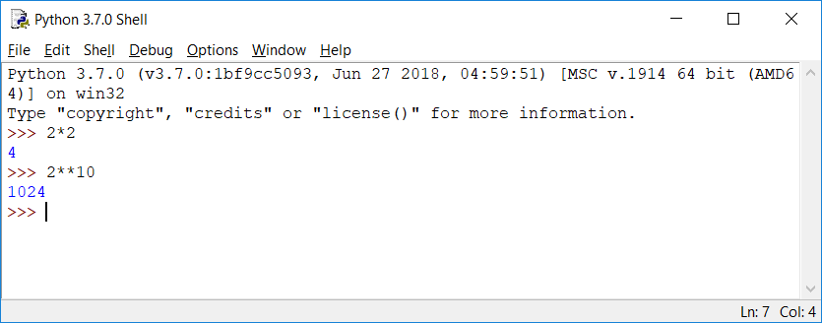

## IDLE – create a new python file

Start IDLE, as above.

Select File Menu 🡪 New File

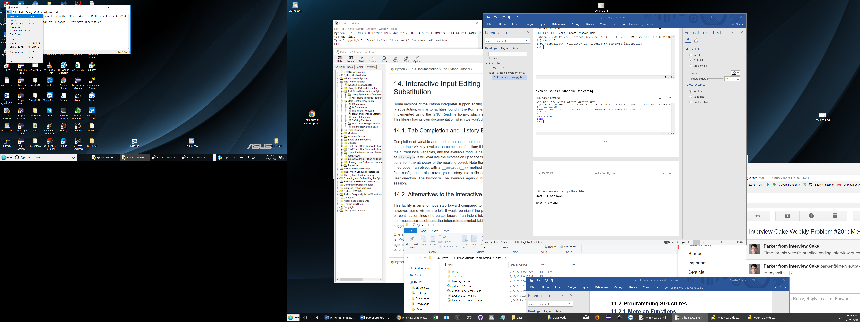

The following text window appears.

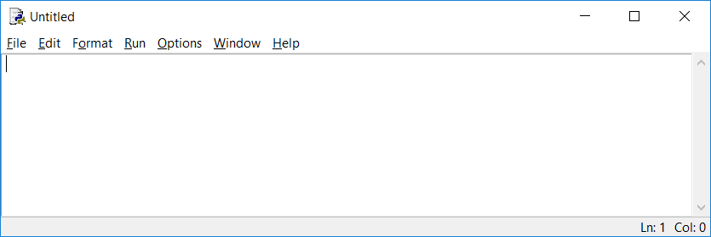

Save new file in a folder you can easily remember:

File 🡪 Save As…

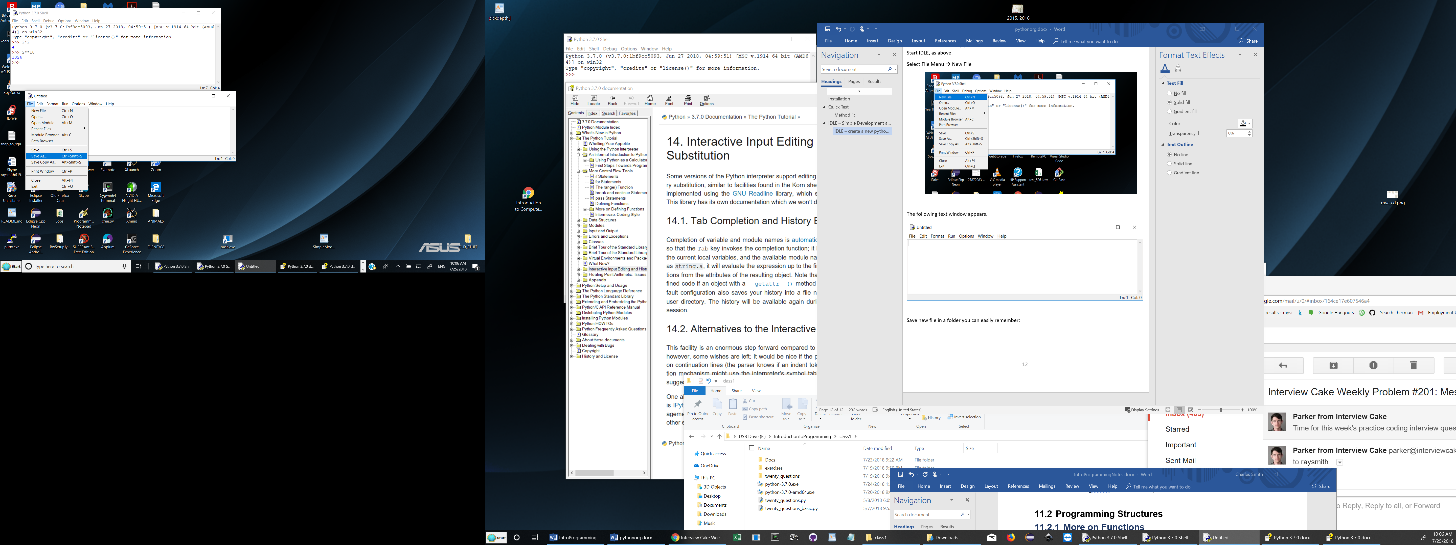

The Save As dialog box appears. Using this box, navigate to a folder of your choice. Type in the file name you want (e.g., first.py), then click Save.

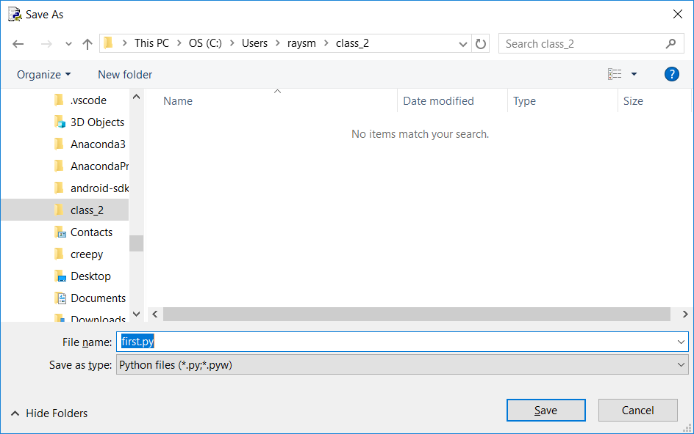

## Creating a new code folder

Using the Save As dialog box, you can navigate to a folder of your choice, and then create a new folder as shown in the folder below:

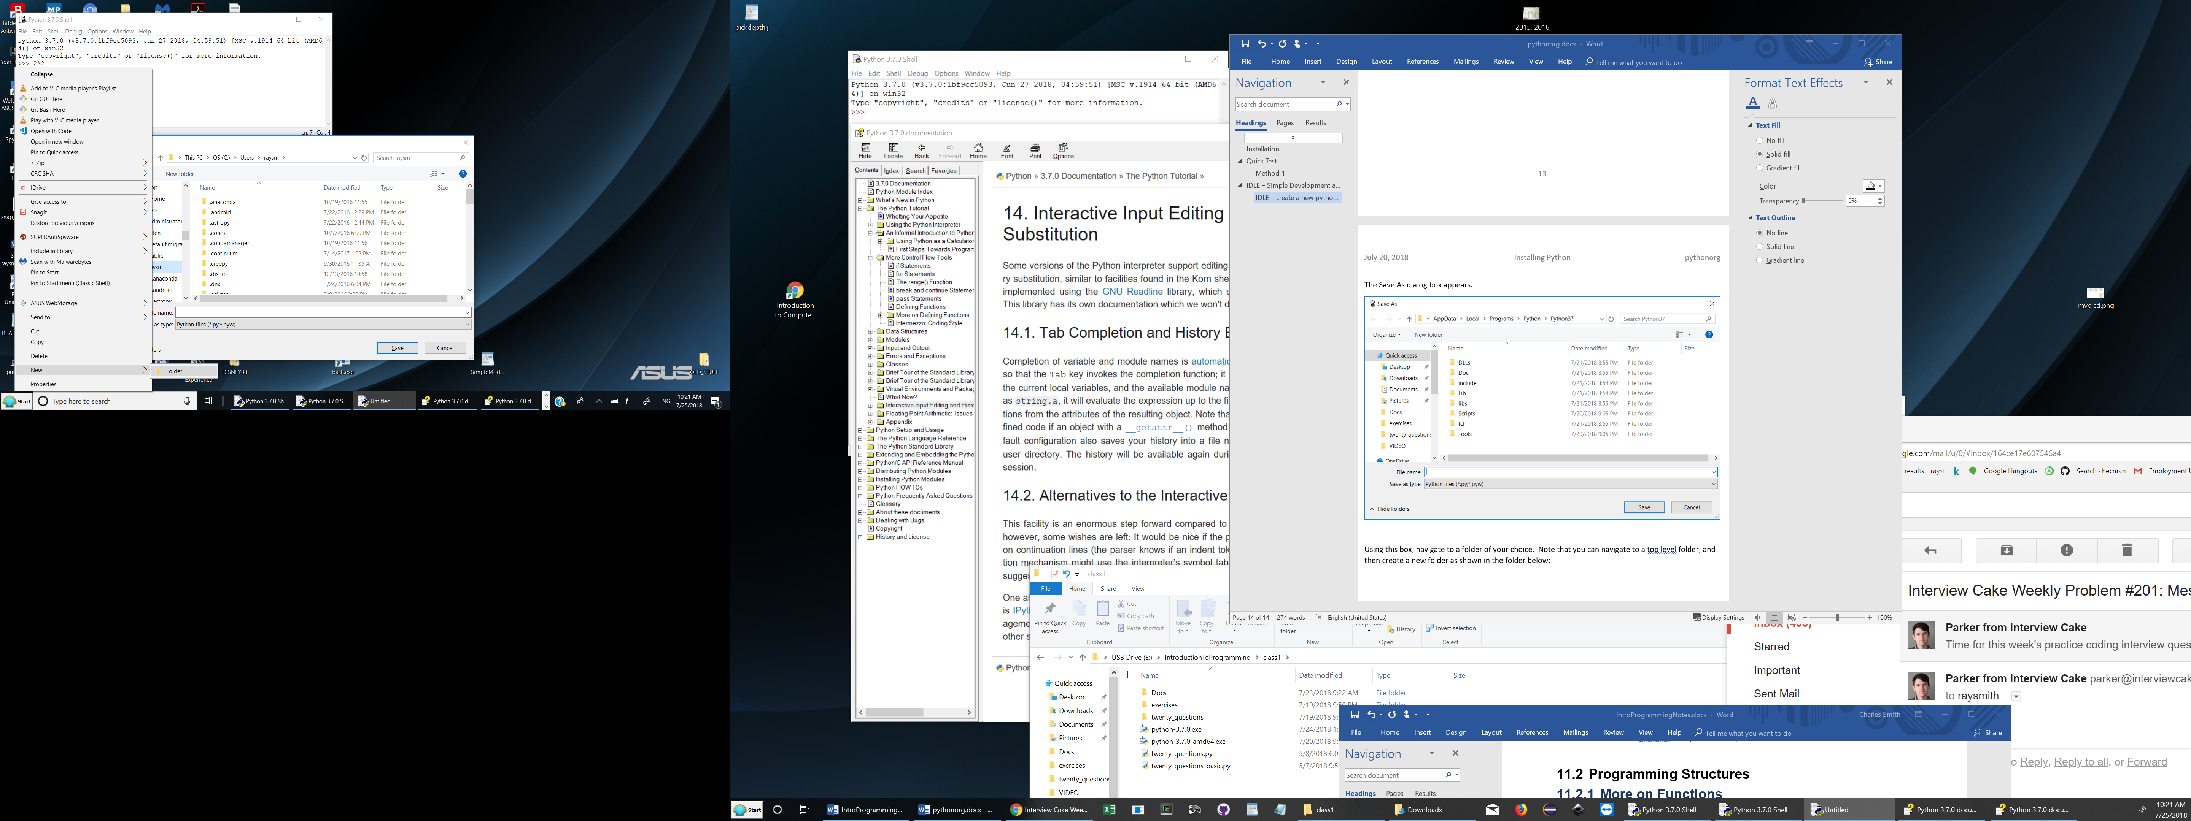

A new folder is created which you can type in the name you want:

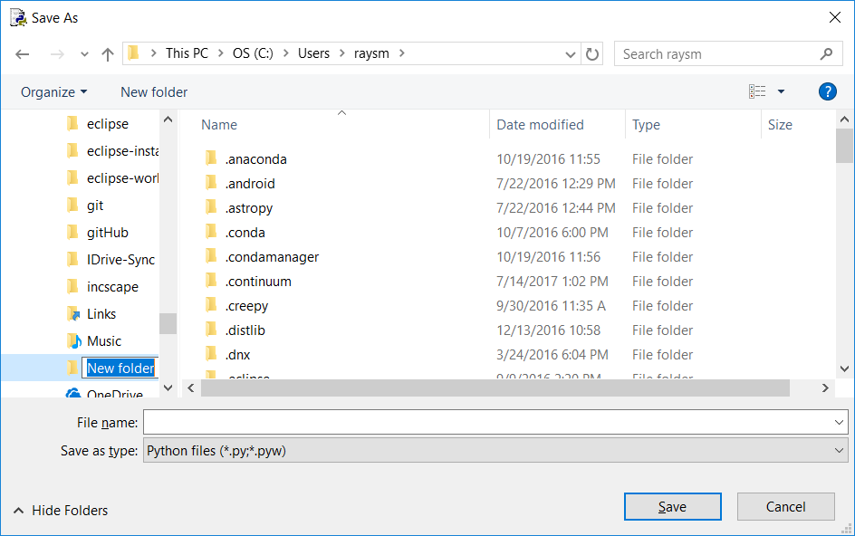

## Making / Changing / Running a Program

### Reading a saved file for edit / running

File 🡪 Open

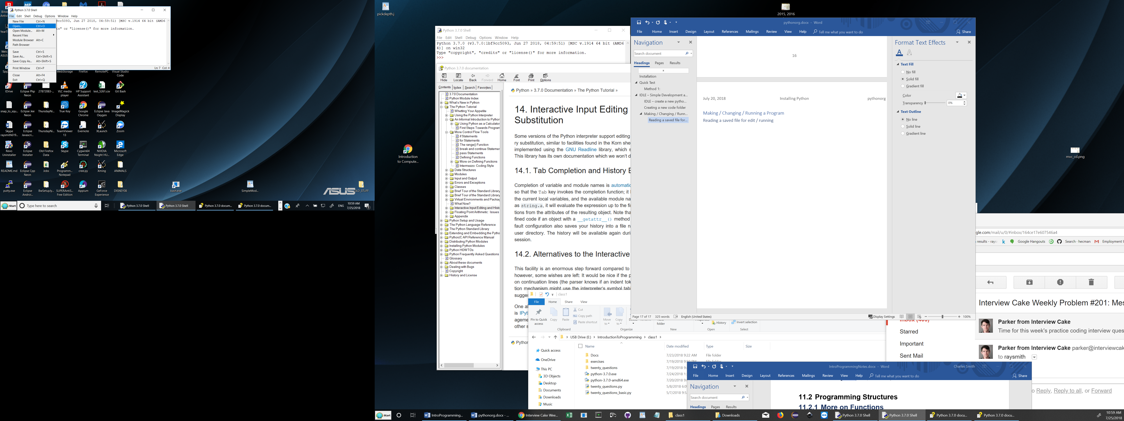

After navigating to desired folder, having a file.

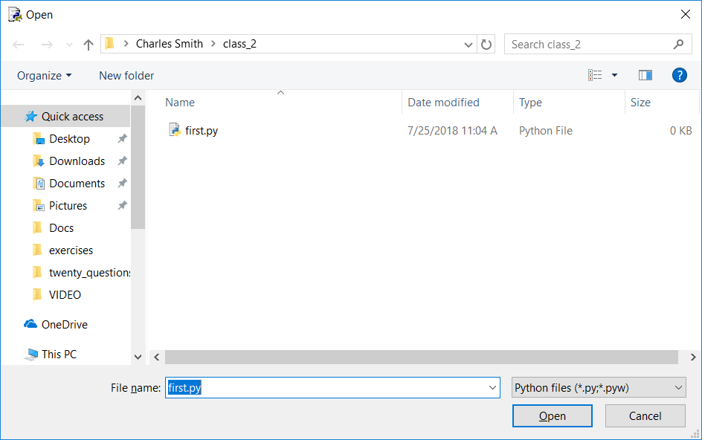

Select file desired or type name in File name field, then click Open.



New or empty file – type in your program, e.g., "Hello World!"

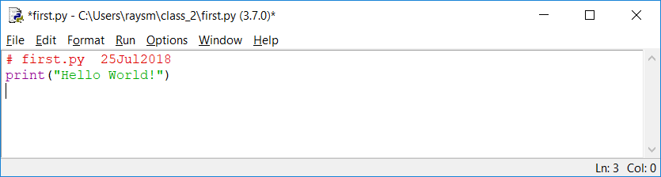

Run this program by clicking Run 🡪 Run Module

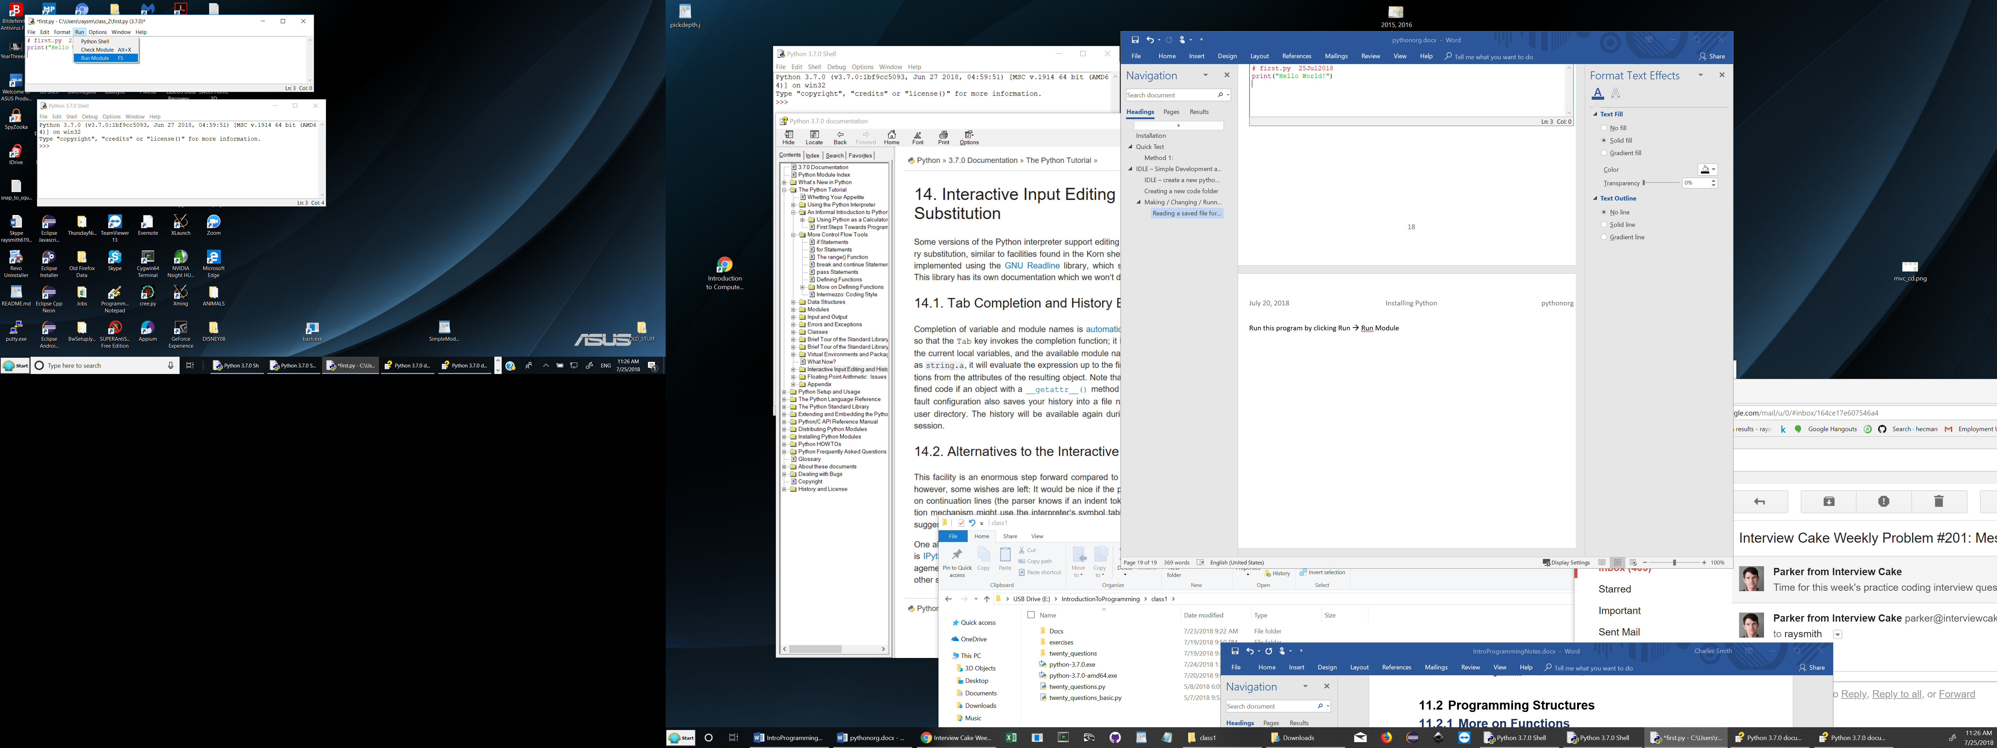

If you have not saved the changes, you will see the following dialog box. Please click OK

